**Project report on**

MOVIE TICKET RESERVATION SYSTEM

Language used: C++

Submitted by:

Rajalakshmi R

DATE: 10 February 2020

ACKNOWLEDGEMENT

This is our time to thank everyone who has been a part of this project. I express my gratitude and sincere thanks to my principal Dr.VasanthiThiagarajan for the moral support extended during the tenure of the project.

This project has been completely under the supervision of my computer science teacher Mrs.P.Bhuvaneswari. I am highly indebted to a able guidance, valuable suggestion during the course of the project.

In the end, am grateful to my partner, my parents and other faculty members for their valuable suggestions for completing the project.

INDEX

• OVERVIEW OF C++……………………………

• PROJECT OVERVIEW…………………………

• REQUIREMENT ……………………………….

• CLASSES AND HEADER FILES …………….

• SOURCE CODE………………………………...

• SAMPLE OUTPUTS……………………………

• CONCLUSION………………………………….

• BIBLIOGRAPHY……………………………….

OVERVIEW OF C++

C++ was designed at AT&T and Bell Labs by Bjarne strousstrup in the early 80’snearly 30 years ago

The original cfront translated c++ into c for portability

* However ,this was difficult to debug and potentially insufficient.

Many native host machines compilers now exist

* E.g.,c++ builder,clang,comeau c/c++,gcc,intelc++ compiler

Microsoft visual c++,sunstudio,etc

C++ is a mostly upwardly compatible extension of c that provides.

1. Stronger type checking

2. Support for data abstraction

3. Support for object-oriented programming

4. Support for generic programming.

Major c++ enhancement

1. c++ supports data abstraction &encapsulation

* E.g., the class mechanism & name spaces

2. c++ supports object-oriented programming features

* E.g., abstract classes ,inheritance

3. c++ supports generic programming

* E.g., parameterized types

4. c++ supports sophisticated error handling.

PROJECT OVERVIEW

The project titled “MOVIE TICKET RESERVATION TICKET” is software developed in C++ language to reserve tickets for your favorite movie.

The movie ticket reservation system automates the basic functions that are used in a websites to book a ticket. It supports functions to display, insert, delete the movie details and book a ticket your favorite movie...etc.

This program also maintains lots of details about movies .This software aims to make the system userfriendly and efficient.

The menu driven program has been developed in order to perform the various activities with the data files according to the user’s choice.

Hence, this project implements the concepts of object oriented programming such as Data abstraction, Data encapsulation, Data hiding and Modularity.

REQUIREMENTS

SOFTWARE REQUIREMENTS:

* Turbo C++ Ide
* Windows Operating System
* Minimum Of 40gb Hard Disk

HARDWARE REQUIREMENTS

* Table
* Keyboard
* Mouse
* Central processing unit(CPU).

CLASS AND HEADER FILES

The class that is used in this program is

* Movie

The header files used are

* #include<fstream.h>
* #include<conio.h>
* #include<dos.h>
* #include<string.h>
* #include<ctype.h>
* #include<stdio.h>
* #include<process.h>
* #include<graphics.h>
* #include<stdlib.h>

SOURCE CODE

**#include<fstream.h>**

**#include<conio.h>**

**#include<string.h>**

**#include<ctype.h>**

**#include<stdio.h>**

**#include<process.h>**

**#include<graphics.h>**

**#include<dos.h>**

**#include<stdlib.h>**

**void format(char x='=',int n=79)**

**{cout<<"\n";**

**for(int i=1;i<=n;i++)**

**cout<<x;**

**cout<<"\n"; }**

**class movie //Main Class**

**{ charmname[25];**

**charlang[20];**

**charcerti[3];**

**longintmovieid;**

**int duration;**

**charhname[30];**

**int rate;**

**public:**

**void in() //Member function to get movie details**

**{ cout<<"ENTER THE MOVIE NAME :";**

**gets(mname);**

**cout<<"ENTER THE LANGUAGE :";**

**gets(lang);**

**cout<<"ENTER THE CERTIFICATION :";**

**gets(certi);**

**cout<<"ENTER THE MOVIE ID :";**

**cin>>movieid;**

**cout<<"ENTER THE DURATION IN MINS :";**

**cin>>duration;**

**cout<<"ENTER THE HERO NAME :";**

**gets(hname);**

**cout<<"ENTER THE RATING FOR 5 :";**

**cin>>rate; }**

**voiddisp() //Member function to diplay movie details**

**{ cout<<"\n\n\tMOVIE ID :";cout<<movieid;**

**cout<<"\t\n\tMOVIE NAME :";puts(mname);**

**cout<<"\tLANGUAGE :";puts(lang);**

**cout<<"\tCERTIFICATION :";puts(certi);**

**cout<<"\tDURATION :";cout<<duration<<" min";**

**cout<<"\t\n\tHERO NAME :";puts(hname);**

**cout<<"\tRATING FOR 5 :";cout<<rate;**

**cout<<"\n\n"; }**

**longintretid() //Function to return movieid**

**{ returnmovieid; }**

**};**

**char name[20];**

**char mail[40];**

**charph[12];**

**voidticin()**

**{ cout<<"\nENTER YOUR NAME :";**

**gets(name);**

**cout<<"\nENTER YOUR CONTACT NO :";**

**gets(ph);**

**cout<<"\nENTER EMAIL ID :";**

**gets(mail); }**

**void ticout()**

**{ cout<<"\nCUSTOMER NAME :";**

**puts(name);**

**cout<<"\nCONTACT NO OF CUSTOMER :";**

**puts(ph);**

**cout<<"\nCUSTOMER EMAIL ID :";**

**puts(mail); }**

**voidlineprint(char x='*') //Function to display a line of**

**{ cout<<"\n";**

**for(int i=1;i<=80;i++)**

**cout<<x;**

**cout<<"\n"; }**

**void display() //Function to display movie details**

**{ clrscr();**

**movie m;**

**ifstream f;**

**cout<<"\n \4\4 MOVIES LIST \4\4\n";**

**f.open("zineamovies.dat",ios::in|ios::binary);**

**while(f.read((char*)&m,sizeof(m)))**

**{ m.disp();**

**format('-',40);**

**gotoxy(10,31);**

**cout<<"PRESS ANY KEY....";**

**getch();**

**}**

**f.close(); }**

**void disp2( int a) //Function to display movie details**

**{ movie m2; //in bill**

**ifstream f2;**

**f2.open("zineamovies.dat",ios::in|ios::binary);**

**while(f2.read((char*)&m2,sizeof(m2)))**

**{ if(m2.retid()==a)**

**m2.disp(); }**

**f2.close(); }**

**void func1() //Function to admin side**

**{ clrscr();**

**int ch1;**

**charoldpass[20];**

**char pass[20];**

**charnewpass[20];**

**charverifyp[20];**

**l1:**

**clrscr();**

**format();**

**cout<<"\n WELCOME TO MAX MOVIE COMPLEX ";**

**format();**

**cout<<"\n\t\t\t\tLOGIN SCREEN\n";**

**cout<<"\n\n\tUser Name:"<<" Maxmoviecomplex";**

**cout<<"\n\n\n\tEnter the Password:";**

**for(int x=0;x<8;x++)**

**{ pass[x]=getch();**

**cout<<"*";**

**}**

**pass[x]='\0';**

**if (strcmpi(pass,"password")==0)**

**{**

**cout<<"\n\n\t\t\t\tLogin Successful!!!";**

**getch();**

**}**

**else**

**{ cout<<"\n\t\t OOPS... Try again";**

**getch();**

**goto l1;}**

**cout<<"\nYOUR PASSWORD IS TOO OLD";**

**cout<<"\n\n1.CHANGE THE PASSWORD RIGHT NOW.\n\n2.CHANGE THE PASSWORD LATER.";**

**cout<<"\n\nENTER YOUR CHOICE:";**

**cin>>ch1;**

**clrscr();**

**switch(ch1)**

**{**

**case 1:cout<<"\nENTER YOUR OLD PASSWORD:";**

**gets(oldpass);**

**if(strcmpi(oldpass,pass)==0)**

**{**

**a1:cout<<"\nENTER YOUR NEW PASSWORD OF 8 CHARACTERS:";**

**gets(newpass);**

**if(strlen(newpass)>8)**

**{**

**cout<<"\nYOUR PASSWORD EXCEEDS 8 CHARACTERS";**

**goto a1;**

**}**

**cout<<"\nVERIFY YOUR NEW PASSWORD:";**

**gets(verifyp);**

**if(strcmpi(verifyp,newpass)==0)**

**{ cout<<"\nPASSWORD MATCHES..";**

**getch();**

**strcpy(pass,newpass);**

**cout<<"\nPASSWORD CHANGED....";**

**getch(); }**

**else**

**{ getch();**

**cout<<"\nPASSWORD DOESNOT MATCH..."<<"\nTRY AGAIN LATER...";**

**getch();} }**

**else**

**{**

**cout<<"\n THE OLD PASSWORD ENTERED IS WRONG";**

**cout<<"\nTRY AGAIN LATER";**

**getch();**

**goto l1; }**

**break;**

**case 2:**

**cout<<"\nCHANGE YOUR PASSWORD SOON";**

**getch();**

**break;**

**default:cout<<"\nPRESS ANY KEY...";**

**getch();**

**break; }**

**intch;**

**l2:**

**clrscr();**

**format('*');**

**cout<<" \3\3\3 MAX MULTIPLEX \3\3\3";**

**format('*');**

**cout<<"\n\t1.DISPLAY THE MOVIES\n\t2.ADD A NEW MOVIE\n\t3.DELETE A MOVIE\n\t4.EXIT";**

**format('*');**

**cout<<"\n\t SELECT ANY ONE OPTION:";**

**cin>>ch;**

**switch(ch)**

**{ case 1:**

**display();**

**break;**

**case 2:**

**ofstream g;**

**char c;**

**movie n;**

**g.open("zineamovies.dat",ios::app|ios::binary);**

**do**

**{ n.in();**

**g.write((char*)&n,sizeof(n));**

**cout<<"PRESS Y TO ADD MORE INPUTS\n";**

**cin>>c;**

**} while (c=='y'||c=='Y');**

**g.close();**

**break;**

**case 3:**

**movie m1;**

**ifstream f2;**

**ofstream f3;**

**int found=0;**

**f2.open("zineamovies.dat",ios::in|ios::binary);**

**f3.open("temp.dat",ios::out|ios::binary);**

**cout<<"\nENTER THE MOVIE ID TO BE DELETED:";**

**intt_id;**

**cin>>t_id;**

**while(f2.read((char*)&m1,sizeof(m1)))**

**{**

**if(t_id!=m1.retid())**

**f3.write((char*)&m1,sizeof(m1));**

**else**

**found=1;**

**}**

**f2.close();**

**f3.close();**

**if(found==1)**

**cout<<"\nRECORD HAS BEEN SUCCESSFULLY DELETED";**

**else**

**cout<<"\nRECORD NOT FOUND";**

**remove("zineamovies.dat");**

**rename("temp.dat","zineamovies.dat");**

**break;**

**case 4:**

**cout<<"\nBACK TO MAIN MENU..";**

**return;**

**default:**

**cout<<"\nINVALID OPTION";**

**}**

**gotoxy(10,24);**

**cout<<"PRESS ANY KEY......";**

**getch();**

**goto l2;**

**}**

**void bill1(intr,char row1[1],char col1[1],char cl)**

**{ //Function to generate bill if no. of seats is 1**

**intgd=DETECT,gm;**

**initgraph(&gd,&gm,"\c:\\tc\\bgi");**

**int x=317,y=236;**

**int v1=0,v2=0,v3=0,num=0,n=0;**

**while(1)**

**{**

**cleardevice();**

**gotoxy(40,15);**

**cout<<num<<"%";**

**setcolor(YELLOW);**

**outtextxy(282,80,"PREPARING YOUR TICKET BILL");**

**setlinestyle(0,0,3);**

**setcolor(GREEN);**

**arc(x,y,270+v2,90+v2,40);**

**setcolor(LIGHTRED);**

**arc(x,y,320-v2,120-v2,70);**

**arc(x,y,320-v2,120-v2,72);**

**setcolor(CYAN);**

**arc(x,y,30+v1,160+v1,920);**

**setcolor(BLUE);**

**arc(x,y,300-v1,40-v1,111);**

**setcolor(LIGHTMAGENTA);**

**arc(x,y,300+v3,140+v3,131);**

**arc(x,y,300+v3,140+v3,133);**

**if(num>=100)**

**{**

**num+=0;**

**delay(500);**

**cleardevice();**

**setcolor(YELLOW);**

**outtextxy(200,150,"BILL IS READY");**

**setcolor(MAGENTA);**

**outtextxy(180,300,"PRESS ANY KEY TO SEE..");**

**getch();**

**closegraph();**

**goto r1;**

**}**

**v1+=4+rand()%8;**

**v2+=6+rand()%8;**

**v3+=3+rand()%8;**

**randomize();**

**num=num+n;**

**n=rand()%2;**

**delay(30);**

**}**

**r1: clrscr();**

**float amount;**

**format('-');**

**cout<<"\n\t\t\t\t MAX MULTIPLEX ";**

**format('-');**

**cout<<"\n\t\t\t\t ---BILL--- ";**

**cout<<"\nTHE TICKET DETAILS ARE:";**

**ticout();**

**cout<<"\n\tNumber Of Seats: "<<r;**

**cout<<"\n\tSeat Number: ";**

**cout<<"\n\t\t"<<row1<<col1;**

**cout<<"\n\tCost Per Ticket:";**

**if(cl=='g')**

**{**

**amount=r*300;**

**cout<<"Rs.300";**

**cout<<"\n\tClass:Gold";**

**cout<<"\n\tNet Bill Amount:";**

**cout<<"Rs."<<amount<<"/-";**

**cout<<"\n\t\t\t ENJOY THE CINEMATIC MOMENTS!!!";**

**}**

**if(cl=='p')**

**{**

**amount=r*500;**

**cout<<"Rs.500";**

**cout<<"\n\tClass:Platinum";**

**cout<<"\n\tNet Bill Amount:";**

**cout<<"Rs."<<amount<<"/-";**

**cout<<"\n\t\t\t ENJOY THE CINEMATIC MOMENTS!!!";**

**}**

**getch(); }**

**void bill2(intr,char row1[1],char col1[1],char row2[1],char col2[1],char cl) //Function to generate bill if no. of**

**{ //seats is 2**

**intgd=DETECT,gm;**

**initgraph(&gd,&gm,"\c:\\tc\\bgi");**

**int x=317,y=236;**

**int v1=0,v2=0,v3=0,num=0,n=0;**

**while(1)**

**{**

**cleardevice();**

**gotoxy(40,15);**

**cout<<num<<"%";**

**setcolor(YELLOW);**

**outtextxy(282,80,"PREPARING YOUR TICKET BILL");**

**setlinestyle(0,0,3);**

**setcolor(GREEN);**

**arc(x,y,270+v2,90+v2,40);**

**setcolor(LIGHTRED);**

**arc(x,y,320-v2,120-v2,70);**

**arc(x,y,320-v2,120-v2,72);**

**setcolor(CYAN);**

**arc(x,y,30+v1,160+v1,920);**

**setcolor(BLUE);**

**arc(x,y,300-v1,40-v1,111);**

**setcolor(LIGHTMAGENTA);**

**arc(x,y,300+v3,140+v3,131);**

**arc(x,y,300+v3,140+v3,133);**

**if(num>=100)**

**{**

**num+=0;**

**delay(500);**

**cleardevice();**

**setcolor(YELLOW);**

**outtextxy(200,150,"BILL IS READY");**

**setcolor(MAGENTA);**

**outtextxy(180,300,"PRESS ANY KEY TO SEE..");**

**getch();**

**closegraph();**

**goto r2;**

**}**

**v1+=4+rand()%8;**

**v2+=6+rand()%8;**

**v3+=3+rand()%8;**

**randomize();**

**num=num+n;**

**n=rand()%2;**

**delay(30);**

**}**

**r2: clrscr();**

**float amount;**

**cout<<"\n-------------------------------------------------------------------------------";**

**cout<<"\n\t\t\t\tMAX MULTIPLEX ";**

**cout<<"\n------------------------------------------------------------------------------- ";**

**cout<<"\n\t\t\t\t ---BILL---";**

**cout<<"\nTHE TICKET DETAILS ARE:";**

**ticout();**

**cout<<"\n\tNumber Of Seats: "<<"2";**

**cout<<"\n\tSeat Numbers: ";**

**cout<<"\n\t\tSeat 1:"<<row1<<col1;**

**cout<<"\n\t\tSeat 2:"<<row2<<col2;**

**cout<<"\n\tCost Per Ticket:";**

**if(cl=='g')**

**{**

**amount=r*300;**

**cout<<"Rs.300";**

**cout<<"\n\tNet Bill Amount:";**

**cout<<"Rs."<<amount<<"/-";**

**cout<<"\n\t\t\t ENJOY THE CINEMATIC MOMENTS!!!";**

**}**

**if(cl=='p')**

**{**

**amount=r*500;**

**cout<<"Rs.500";**

**cout<<"\n\tNet Bill Amount:";**

**cout<<"Rs."<<amount<<"/-";**

**cout<<"\n\t\t\t ENJOY THE CINEMATIC MOMENTS!!!";**

**}**

**getch();**

**}**

**void bill3(intr,char row1[1],char col1[1],char row2[1],char col2[1],char row3[1],char col3[1],char cl)**

**{ intgd=DETECT,gm;**

**initgraph(&gd,&gm,"\c:\\tc\\bgi");**

**int x=317,y=236;**

**int v1=0,v2=0,v3=0,num=0,n=0;**

**while(1)**

**{**

**cleardevice();**

**gotoxy(40,15);**

**cout<<num<<"%";**

**setcolor(YELLOW);**

**outtextxy(282,80,"PREPARING YOUR TICKET BILL");**

**setlinestyle(0,0,3);**

**setcolor(GREEN);**

**arc(x,y,270+v2,90+v2,40);**

**setcolor(LIGHTRED);**

**arc(x,y,320-v2,120-v2,70);**

**arc(x,y,320-v2,120-v2,72);**

**setcolor(CYAN);**

**arc(x,y,30+v1,160+v1,920);**

**setcolor(BLUE);**

**arc(x,y,300-v1,40-v1,111);**

**setcolor(LIGHTMAGENTA);**

**arc(x,y,300+v3,140+v3,131);**

**arc(x,y,300+v3,140+v3,133);**

**if(num>=100)**

**{**

**num+=0;**

**delay(500);**

**cleardevice();**

**setcolor(YELLOW);**

**outtextxy(200,150,"BILL IS READY");**

**setcolor(MAGENTA);**

**outtextxy(180,300,"PRESS ANY KEY TO SEE..");**

**getch();**

**closegraph();**

**goto r3;**

**}**

**v1+=4+rand()%8;**

**v2+=6+rand()%8;**

**v3+=3+rand()%8;**

**randomize();**

**num=num+n;**

**n=rand()%2;**

**delay(30);**

**}**

**//Function to generate bill if no. of seat is 3**

**r3: clrscr();**

**float amount;**

**cout<<"\n-------------------------------------------------------------------------------";**

**cout<<"\n\t\t\t\t MAX MULTIPLEX ";**

**cout<<"\n------------------------------------------------------------------------------- ";**

**cout<<"\n\t\t\t\t ---BILL---";**

**cout<<"\nTHE TICKET DETAILS ARE:";**

**ticout();**

**cout<<"\n\tNumber Of Seats: "<<r;**

**cout<<"\n\tSeat Numbers: ";**

**cout<<"\n\t\tSeat 1:"<<row1<<col1;**

**cout<<"\n\t\tSeat 2:"<<row2<<col2;**

**cout<<"\n\t\tSeat 3:"<<row3<<col3;**

**cout<<"\n\tCost Per Ticket:";**

**if(cl=='g')**

**{**

**amount=r*300;**

**cout<<"Rs.300";**

**cout<<"\n\tNet Bill Amount:";**

**cout<<"Rs."<<amount<<"/-";**

**cout<<"\n\t\t\t ENJOY THE CINEMATIC MOMENTS!!!";**

**}**

**if(cl=='p')**

**{**

**amount=r*500;**

**cout<<"Rs.500";**

**cout<<"\n\tNet Bill Amount:";**

**cout<<"Rs."<<amount<<"/-";**

**cout<<"\n\t\t\t ENJOY THE CINEMATIC MOMENTS!!!";**

**}**

**getch(); }**

**void bill4(intr,char row1[1],char col1[1],char row2[1],char col2[1],char row3[1],char col3[1],char row4[1],char col4[1],char cl)**

**{intgd=DETECT,gm; //Function to generate bill if no. of seats is 4**

**initgraph(&gd,&gm,"\c:\\tc\\bgi");**

**int x=317,y=236;**

**int v1=0,v2=0,v3=0,num=0,n=0;**

**while(1)**

**{ cleardevice();**

**gotoxy(40,15);**

**cout<<num<<"%";**

**setcolor(YELLOW);**

**outtextxy(282,80,"PREPARING YOUR TICKET BILL");**

**setlinestyle(0,0,3);**

**setcolor(GREEN);**

**arc(x,y,270+v2,90+v2,40);**

**setcolor(LIGHTRED);**

**arc(x,y,320-v2,120-v2,70);**

**arc(x,y,320-v2,120-v2,72);**

**setcolor(CYAN);**

**arc(x,y,30+v1,160+v1,920);**

**setcolor(BLUE);**

**arc(x,y,300-v1,40-v1,111);**

**setcolor(LIGHTMAGENTA);**

**arc(x,y,300+v3,140+v3,131);**

**arc(x,y,300+v3,140+v3,133);**

**if(num>=100)**

**{ num+=0;**

**delay(500);**

**cleardevice();**

**setcolor(YELLOW);**

**outtextxy(200,150,"BILL IS READY");**

**setcolor(MAGENTA);**

**outtextxy(180,300,"PRESS ANY KEY TO SEE..");**

**getch();**

**closegraph();**

**goto r4;**

**}**

**v1+=4+rand()%8;**

**v2+=6+rand()%8;**

**v3+=3+rand()%8;**

**randomize();**

**num=num+n;**

**n=rand()%2;**

**delay(30);**

**}**

**r4: clrscr();**

**float amount;**

**cout<<"\n-------------------------------------------------------------------------------";**

**cout<<"\n\t\t\t\tMAX MULTIPLEX ";**

**cout<<"\n-------------------------------------------------------------------------------";**

**cout<<"\n\t\t\t\t ---BILL---";**

**cout<<"\nTHE TICKET DETAILS ARE:";**

**ticout();**

**cout<<"\n\tNumber Of Seats: "<<r;**

**cout<<"\n\tSeat Numbers:";**

**cout<<"\n\t\tSeat 1:"<<row1<<col1;**

**cout<<"\n\t\tSeat 2:"<<row2<<col2;**

**cout<<"\n\t\tSeat 3:"<<row3<<col3;**

**cout<<"\n\t\tSeat 4:"<<row4<<col4;**

**cout<<"\n\tCost Per Ticket:";**

**if(cl=='g')**

**{ amount=r*300;**

**cout<<"Rs.300";**

**cout<<"\n\tNet Bill Amount:";**

**cout<<"Rs."<<amount<<"/-";**

**cout<<"\n\t\t\t ENJOY THE CINEMATIC MOMENTS!!!";**

**}**

**if(cl=='p')**

**{**

**amount=r*500;**

**cout<<"Rs.500";**

**cout<<"\n\tNet Bill Amount:";**

**cout<<"Rs."<<amount<<"/-";**

**cout<<"\n\t\t\t ENJOY THE CINEMATIC MOMENTS!!!";**

**}**

**getch(); }**

**void bill5(intr,char row1[1],char col1[1],char row2[1],char col2[1],char row3[1],char col3[1],char row4[1],char col4[1],char row5[1],char col5[1],char cl)**

**{ intgd=DETECT,gm; //Function to generate bill if no. of seats is 5**

**initgraph(&gd,&gm,"\c:\\tc\\bgi");**

**int x=317,y=236;**

**int v1=0,v2=0,v3=0,num=0,n=0;**

**while(1)**

**{ cleardevice();**

**gotoxy(40,15);**

**cout<<num<<"%";**

**setcolor(YELLOW);**

**outtextxy(282,80,"PREPARING YOUR TICKET BILL");**

**setlinestyle(0,0,3);**

**setcolor(GREEN);**

**arc(x,y,270+v2,90+v2,40);**

**setcolor(LIGHTRED);**

**arc(x,y,320-v2,120-v2,70);**

**arc(x,y,320-v2,120-v2,72);**

**setcolor(CYAN);**

**arc(x,y,30+v1,160+v1,920);**

**setcolor(BLUE);**

**arc(x,y,300-v1,40-v1,111);**

**setcolor(LIGHTMAGENTA);**

**arc(x,y,300+v3,140+v3,131);**

**arc(x,y,300+v3,140+v3,133);**

**if(num>=100)**

**{num+=0;**

**delay(500);**

**cleardevice();**

**setcolor(YELLOW);**

**outtextxy(200,150,"BILL IS READY");**

**setcolor(MAGENTA);**

**outtextxy(180,300,"PRESS ANY KEY TO SEE..");**

**getch();**

**closegraph();**

**goto r5; }**

**v1+=4+rand()%8;**

**v2+=6+rand()%8;**

**v3+=3+rand()%8;**

**randomize();**

**num=num+n;**

**n=rand()%2;**

**delay(30); }**

**r5: clrscr();**

**float amount;**

**cout<<"\n-------------------------------------------------------------------------------";**

**cout<<"\n\t\t\t\tMAX MULTIPLEX ";**

**cout<<"\n-------------------------------------------------------------------------------";**

**cout<<"\n\t\t\t\t ---BILL---";**

**cout<<"\nTHE TICKET DETAILS ARE:";**

**ticout();**

**cout<<"\n\tNumber Of Seats: "<<r;**

**cout<<"\n\tSeat Numbers: ";**

**cout<<"\n\t\tSeat 1:"<<row1<<col1;**

**cout<<"\n\t\tSeat 2:"<<row2<<col2;**

**cout<<"\n\t\tSeat 3:"<<row3<<col3;**

**cout<<"\n\t\tSeat 4:"<<row4<<col4;**

**cout<<"\n\t\tSeat 5:"<<row5<<col5;**

**cout<<"\n\tCost Per Ticket:";**

**if(cl=='g')**

**{ amount=r*300;**

**cout<<"Rs.300";**

**cout<<"\n\tNet Bill Amount:";**

**cout<<"Rs."<<amount<<"/-";**

**cout<<"\n\t\t\t ENJOY THE CINEMATIC MOMENTS!!!";**

**}**

**if(cl=='p')**

**{ amount=r*500;**

**cout<<"Rs.500";**

**cout<<"\n\tNet Bill Amount:";**

**cout<<"Rs."<<amount<<"/";**

**cout<<"\n\t\t\t ENJOY THE CINEMATIC MOMENTS!!!"; }**

**getch();}**

**void seat(int r) //Function for seating arrangements**

**{ format();**

**cout<<"\n\n\t\tA1 | A2 | A3 | A4 | A5 | A6 | A7 | A8 | A9 ";**

**cout<<"\n\n\t\tB1 | B2 | B3 | B4 | B5 | B6 | B7 | B8 | B9";**

**cout<<"\n\n\t\tC1 | C2 | C3 | C4 | C5 | C6 | C7 | C8 | C9";**

**cout<<"\n\n\t\tD1 | D2 | D3 | D4 | D5 | D6 | D7 | D8 | D9";**

**cout<<"\n\n\t\tE1 | E2 | E3 | E4 | E5 | E6 | E7 | E8 | E9";**

**format();**

**char row1[1] , col1[1] , row2[1] , col2[1] , row3[1] , col3[1] , row4[1] , col4[1] ,row5[1],col5[1];**

**char cl;**

**if(r==0)**

**{ cout<<"\nSORRY!! No Are Seats Available!!!";**

**getch();**

**exit(1); }**

**if(r==1)**

**{ cout<<"\nSelect Row(A-E):->";**

**gets(row1);**

**strupr(row1);**

**cout<<"\nSelect Column(1-9):->";**

**gets(col1);**

**cout<<"\nGold Class(g) or Platinum Class(p):";**

**cin>>cl;**

**bill1(r,row1,col1,cl); }**

**if(r==2)**

**{ cout<<"\nSelect Row(A-E) For Seat-1:->";**

**gets(row1);**

**strupr(row1);**

**cout<<"\nSelect Column(1-9) For Seat-1:->";**

**gets(col1);**

**cout<<"\nSelect Row(A-E) For Seat-2:->";**

**gets(row2);**

**strupr(row2);**

**cout<<"\nSelect Column(1-9) For Seat-2:->";**

**gets(col2);**

**cout<<"\nGold Class(g) or Platinum Class(p):";**

**cin>>cl;**

**bill2(r,row1,col1,row2,col2,cl); }**

**if(r==3)**

**{ cout<<"\nSelect Row(A-E) For Seat-1:->";**

**gets(row1);**

**strupr(row1);**

**cout<<"\nSelect Column(1-9) For Seat-1:->";**

**gets(col1);**

**cout<<"\nSelect Row(A-E) For Seat-2:->";**

**gets(row2);**

**strupr(row2);**

**cout<<"\nSelect Column(1-9) For Seat-2:->";**

**gets(col2);**

**cout<<"\nSelect Row(A-E) For Seat-3:->";**

**gets(row3);**

**strupr(row3);**

**cout<<"\nSelect Column(1-9) For Seat-3:->";**

**gets(col3);**

**cout<<"\nGold Class(g) or Platinum Class(p):";**

**cin>>cl;**

**bill3(r,row1,col1,row2,col2,row3,col3,cl); }**

**if(r==4)**

**{ cout<<"\nSelect Row(A-E) For Seat-1:->";**

**gets(row1);**

**strupr(row1);**

**cout<<"\nSelect Column(1-9) For Seat-1:->";**

**gets(col1);**

**cout<<"\nSelect Row(A-E) For Seat-2:->";**

**gets(row2);**

**strupr(row2);**

**cout<<"\nSelect Column(1-9) For Seat-2:->";**

**gets(col2);**

**cout<<"\nSelect Row(A-E) For Seat-3:->";**

**gets(row3);**

**strupr(row3);**

**cout<<"\nSelect Column(1-9) For Seat-3:->";**

**gets(col3);**

**cout<<"\nSelect Row(A-E) For Seat-4:->";**

**gets(row4);**

**strupr(row4);**

**cout<<"\nSelect Column(1-9) For Seat-4:->";**

**gets(col4);**

**cout<<"\nGold Class(g) or Platinum Class(p):";**

**cin>>cl;**

**bill4(r,row1,col1,row2,col2,row3,col3,row4,col4,cl); }**

**if(r==5)**

**{ cout<<"\nSelect Row(A-E) For Seat-1:->";**

**gets(row1);**

**strupr(row1);**

**cout<<"\nSelect Column(1-9) For Seat-1:->";**

**gets(col1);**

**cout<<"\nSelect Row(A-E) For Seat-2:->";**

**gets(row2);**

**strupr(row2);**

**cout<<"\nSelect Column(1-9) For Seat-2:->";**

**gets(col2);**

**cout<<"Select Row(A-E) For Seat-3:->";**

**gets(row3);**

**strupr(row4);**

**cout<<"\nSelect Column(1-9) For Seat-3:->";**

**gets(col3);**

**cout<<"\nSelect Row(A-E) For Seat-4:->";**

**gets(row4);**

**strupr(row4);**

**cout<<"\nSelect Column(1-9) For Seat-4:->";**

**gets(col4);**

**cout<<"\nSelect Row(A-E) For Seat-5:->";**

**gets(row5);**

**strupr(row5);**

**cout<<"\nSelect Column(1-9) For Seat-5:->";**

**gets(col5);**

**cout<<"\nGold Class(g) or Platinum Class(p):";**

**cin>>cl;**

**bill5(r,row1,col1,row2,col2,row3,col3,row4,col4,row5,col5,cl);**

**} }**

**void func2() //Function to admin side**

**{ int a;**

**l3:**

**clrscr();**

**lineprint('=');**

**cout<<" MAX MULTIPLEX ";**

**lineprint('=');**

**cout<<"MAX MULTIPLEX IS THE LARGEST AND MOST POPULAR MOVIE TICKET RESERVATION WEBSITE.";**

**int k;**

**cout<<"\n\n\t\t\t\t1.SELECT THE MOVIE ";**

**cout<<"\n\t\t\t\t2.BACK TO MAIN MENU ";**

**cout<<"\n\n\t\t\t\n ENTER YOUR CHOICE:";**

**cin>>k;**

**switch(k)**

**{ case 1: intse,show,mid;**

**clrscr();**

**cout<<"\nMOVIES AVAILABLE ARE:"<<"\n";**

**display();**

**clrscr();**

**cout<<"\nENTER THE FOLLOWING DETAILS TO CONTINUE THE TICKET BOOKING";**

**ticin();**

**cout<<"\nENTER THE MOVIE ID THAT YOU WISH TO SEE:";**

**cin>>mid;**

**cout<<"\nENTER THE NO OF SEATS (MAX 5):";**

**cin>>se;**

**cout<<"\nENTER THE SHOW YOU WISH TO SEE:\n1.FIRST SHOW\n2.MATINEE SHOW \n3.EVENING SHOW\n4.SECOND SHOW";**

**cout<<"\nENTER THE NUMBER OF THE SHOW:";**

**cin>>show;**

**clrscr();**

**seat(se);**

**goto l3;**

**case 2:**

**return;**

**default:**

**cout<<"\n PRESS ANY VALID KEY..PLEASE";**

**goto l3;**

**} }**

**void main() //Main Program**

**{ textbackground(BLACK);**

**textcolor(LIGHTBLUE);**

**clrscr();**

**int mi;**

**m1:**

**clrscr();**

**lineprint();**

**cout<<" MAX MULTIPLEX";**

**lineprint();**

**cout<<"\n WELCOME TO THE INDIA'S POPULAR MOVIE TICKET RESERVATION WEBSITE.";**

**cout<<"\n\t\t\t 1.ADMIN \n\t\t\t 2.USER \n\t\t\t 3.EXIT";**

**lineprint();**

**gotoxy(30,50);**

**cout<<"\nENTER YOUR CHOICE: ";**

**gotoxy(40,50);**

**cin>>mi;**

**cout<<"\n\n\n\n\n\n\n\n\n\n";**

**switch(mi)**

**{ case 1:**

**func1();**

**break;**

**case 2:**

**func2();**

**break;**

**case 3:**

**exit(1);**

**default:cout<<"\nTHANKYOU";**

**getch();**

**}**

**getch();**

**goto m1;**

**}**

SAMPLE OUTPUT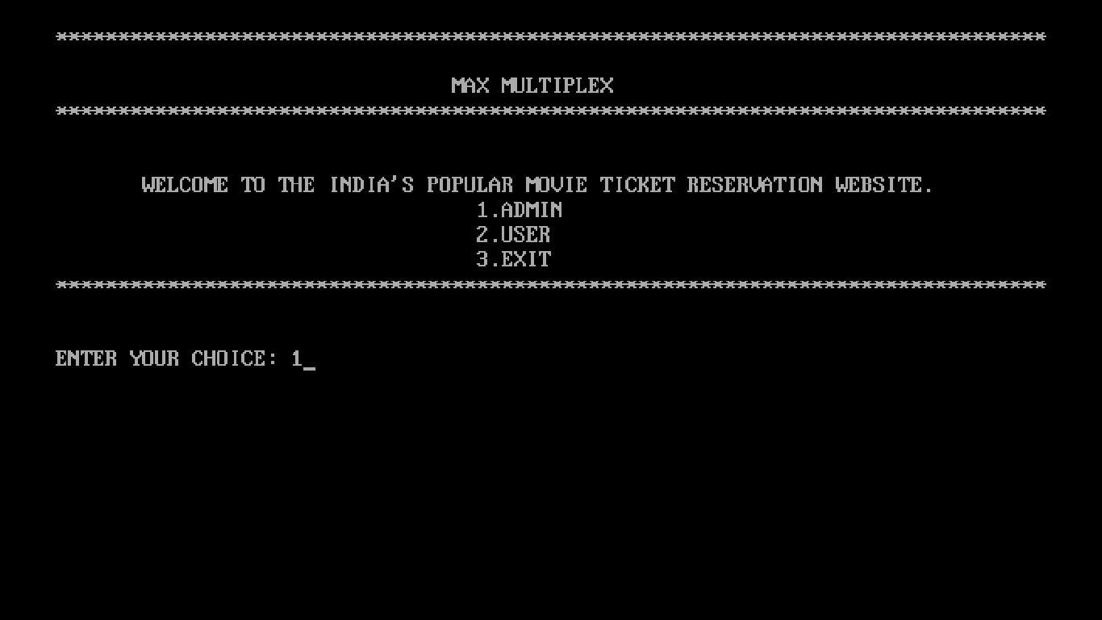

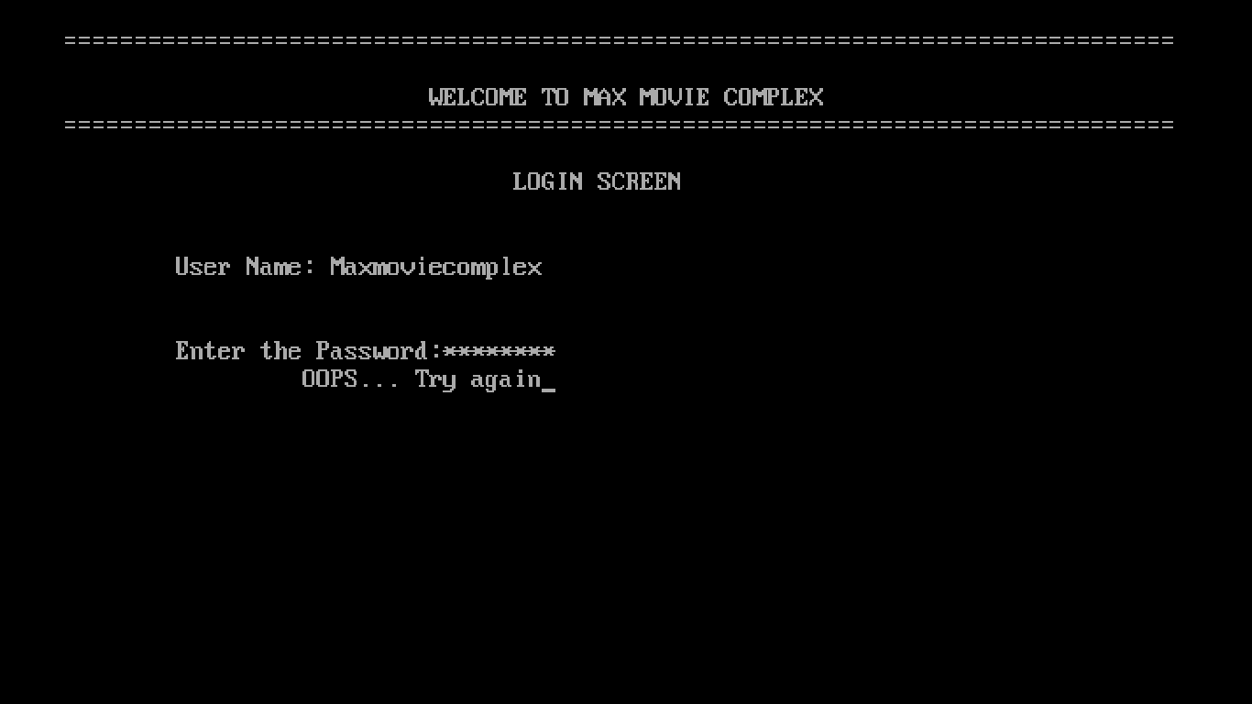

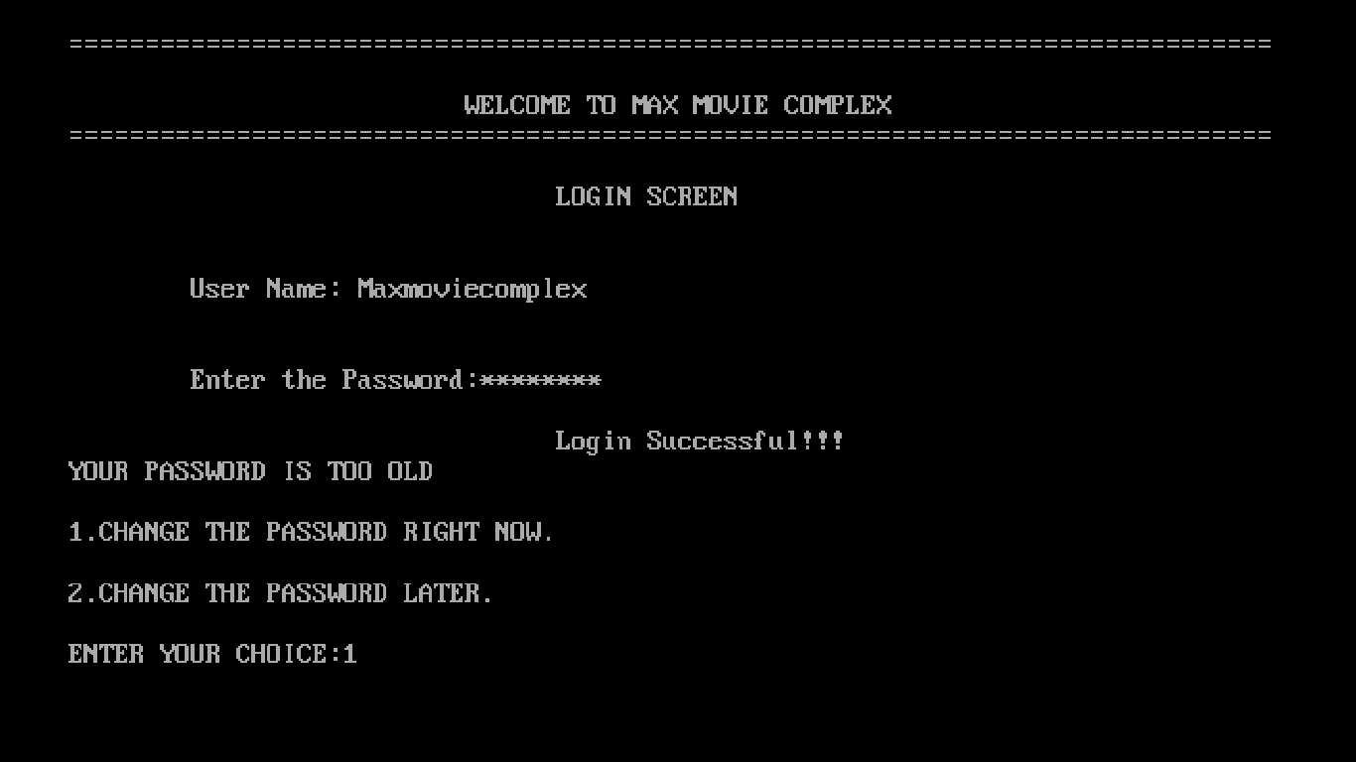

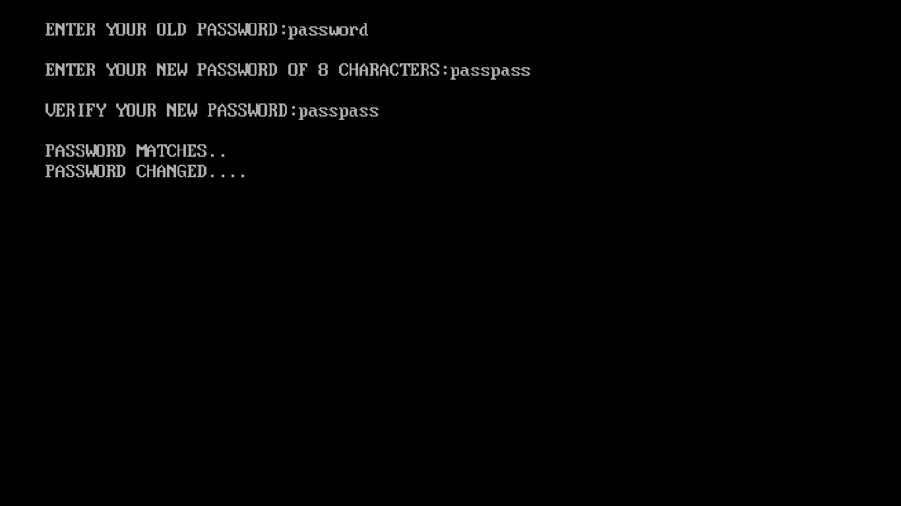

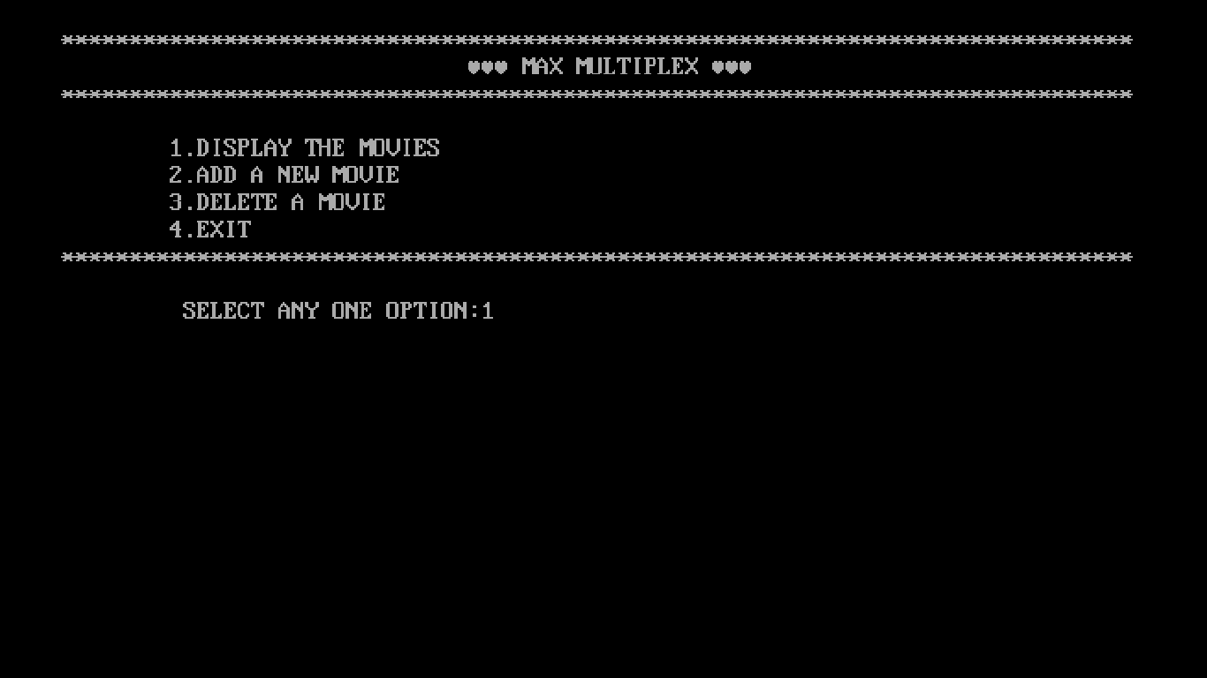

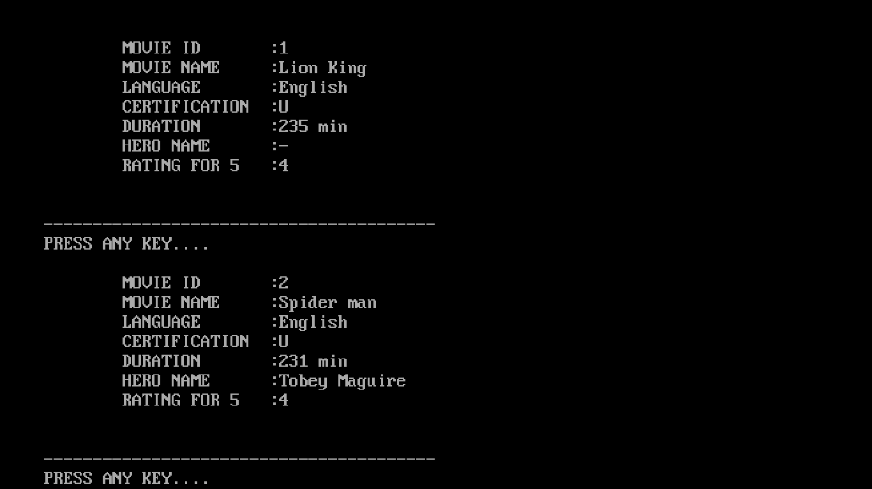

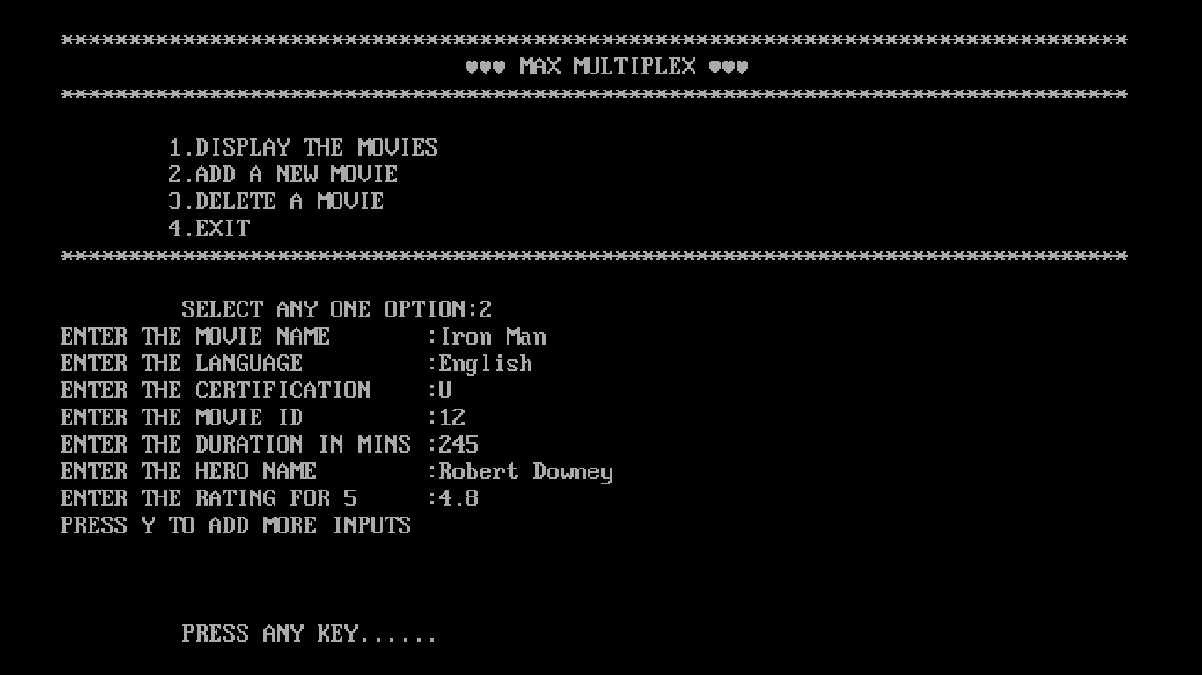

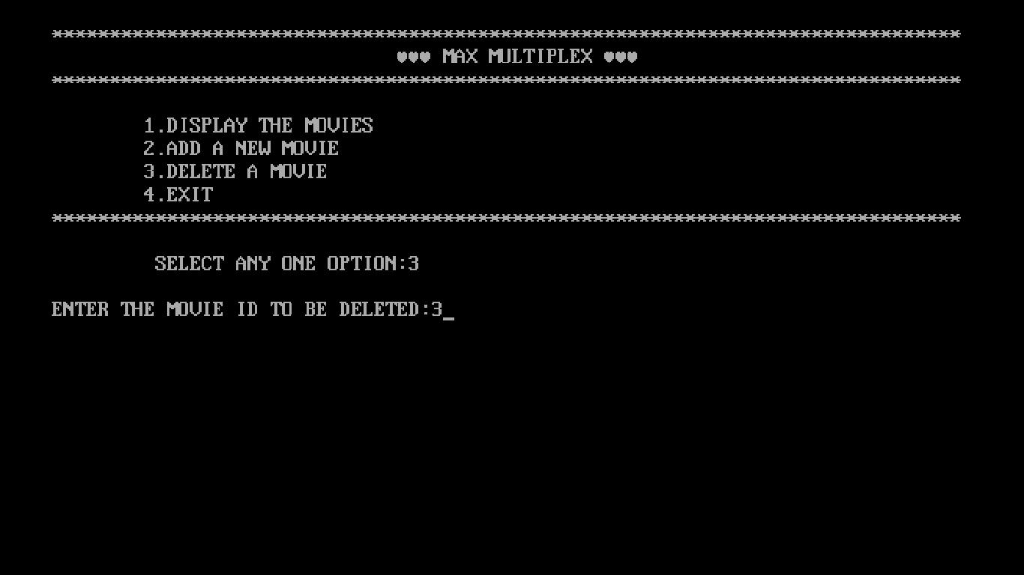

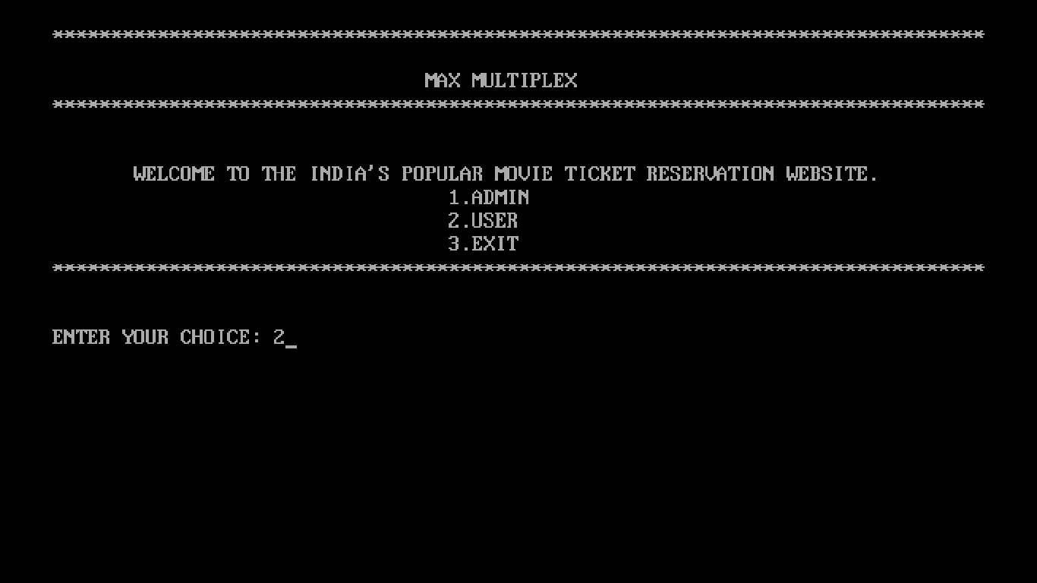

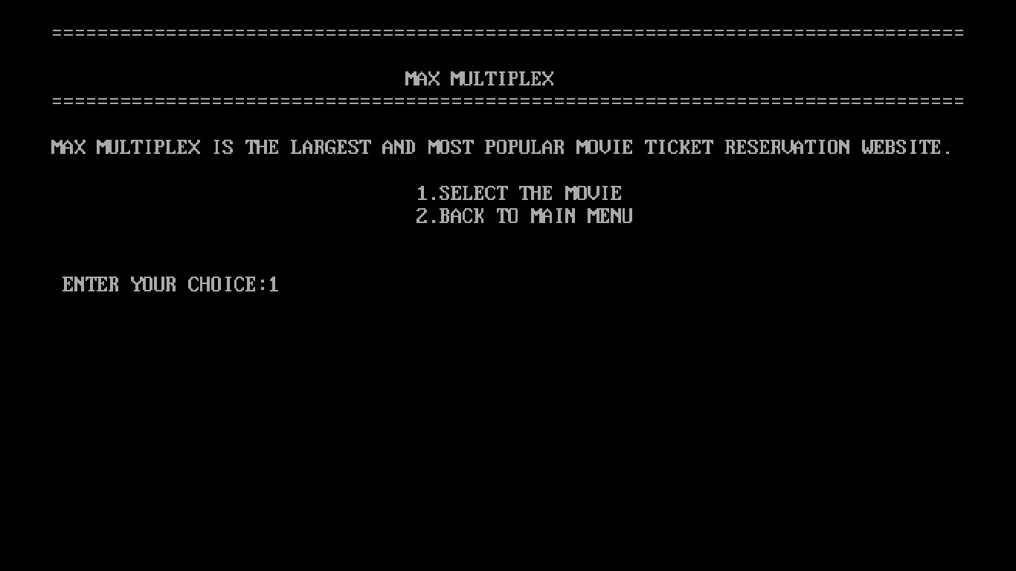

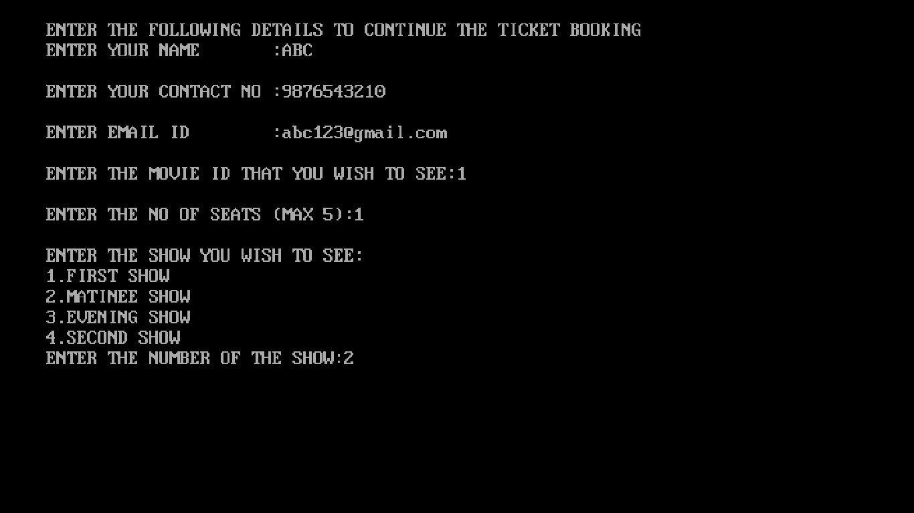

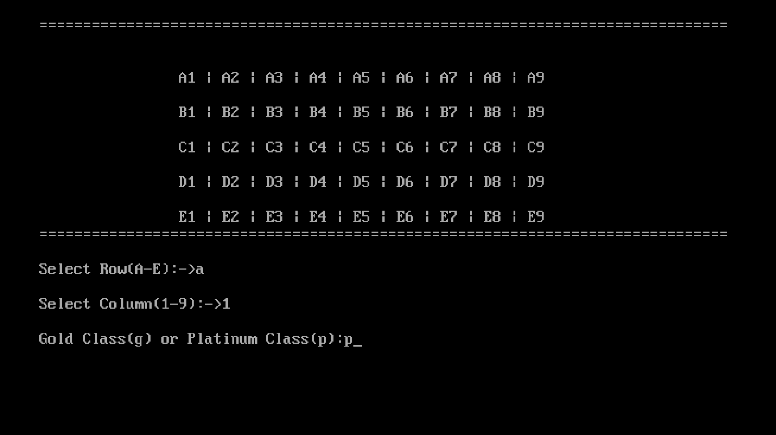

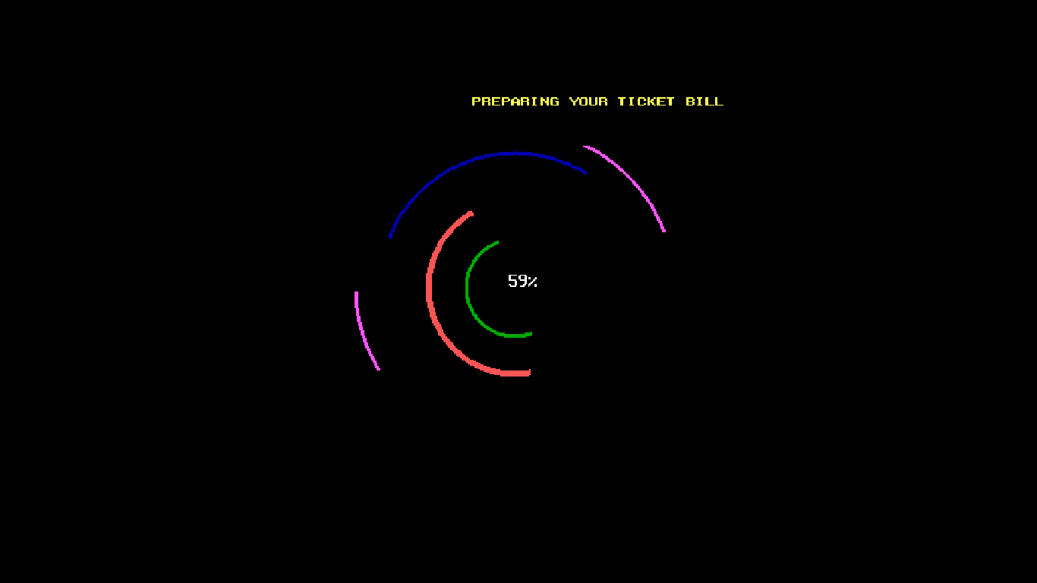

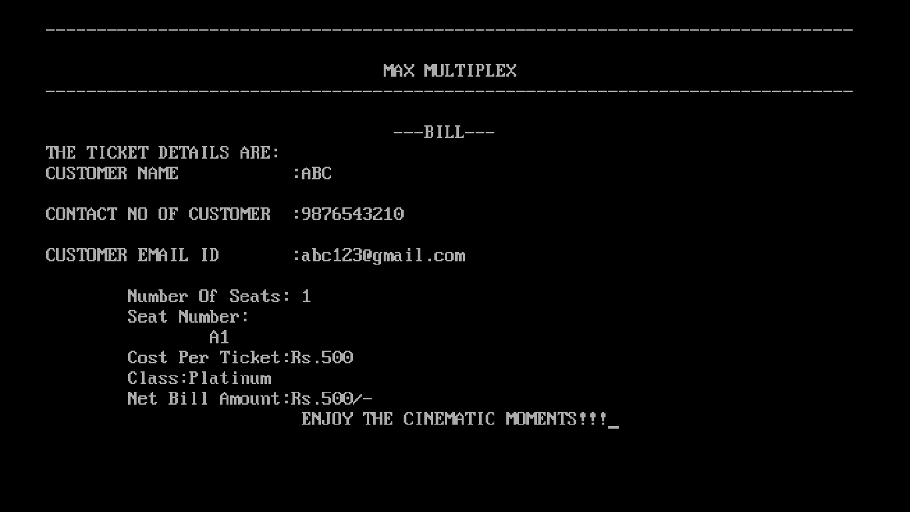

CONCLUSION

This project is about Movie ticket reservation. It deals with just one class-Movie.It can be used with full effect for reserving tickets for your favorite movie.

This program contains graphics to make the program more interesting .This greatly saves time and effort of a normal person and makes ticket booking easy.

Also several additions can be made to this program and thus by we can enhance this software in future.

BIBLIOGRAPHY

* Sumita Arora 12th computer science text book.
* Google
* Wikipedia

